**Project Report**

Contents

(Market basket analysis) 1

a) Plot of the top 10 transactions 2

b) Association rules using minimum support of 0.002, minimum confidence of 0.20, and maximum length of 3 2

c) Compare this rule with the highest lift rule for maximum length of 2 3

# (Market basket analysis)

Loading and reading the transactions data

## Plot of the top 10 transactions

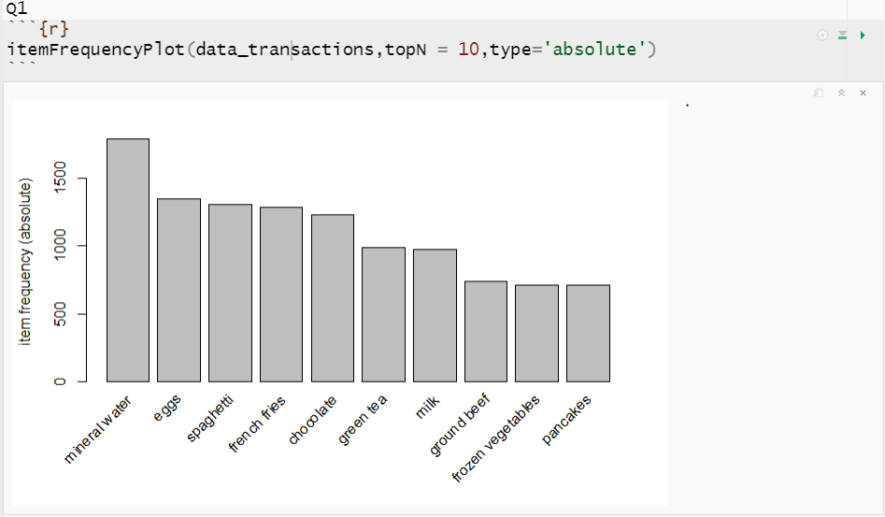

## Association rules using minimum support of 0.002, minimum confidence of 0.20, and maximum length of 3

## Compare this rule with the highest lift rule for maximum length of 2

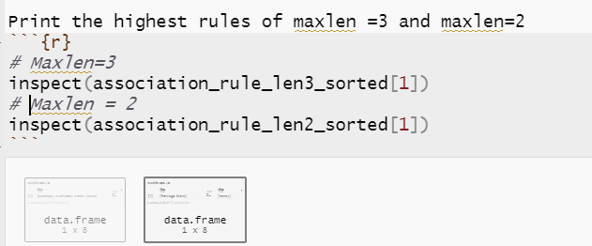

maxlen =3

maxlen=2



I) Better lift: when maxlen=3

Greater support: when maxlen=3

ii) As an industry rule of thumb, the rule which its lift is greater than 1 will be worthy and here both of them are worthy, but I will go with the rule with maxlen=3 because it has the highest lift and that is means strong correlations between items and good association.